|  |
| --- |
| **Karan Arora**  **R.L. Institute M: 9416974837**  **Class : X**  **Chapter : 4**  **“CARBON AND ITS COMPOUNDS”** |

**Assignment – 1**

1. Carbon exists in the atmosphere in the form of :

|  |  |
| --- | --- |
| a) Carbon monoxide only | b) carbon monoxide in traces and carbon dioxide |
| c) carbon dioxide only | d) Coal |

1. Which of the following statement are usually correct for carbon compounds? These

i) Are good conductors of electricity

ii) Are poor conductors of electricity

iii) Have strong forces of attraction between their molecules

iv) Do not have strong forces of attraction between their molecules

|  |  |  |  |
| --- | --- | --- | --- |
| a) (i) & (iii) | b) (ii) & (iii) | c) (i) & (iv) | d) (ii) & (iv) |

1. A molecule of ammonia (NH3) has:

|  |  |
| --- | --- |
| a) only single bonds | b) only double bonds |
| c) only triple bonds | d) 2 double bonds and one single bond |

1. Buckminster fullerene is an allotropic form of

|  |  |  |  |
| --- | --- | --- | --- |
| a) phosphorus | b) sulphur | c) carbon | d) tin |

1. Which of the following are corrects structural isomers of butane?

|  |  |  |  |
| --- | --- | --- | --- |
| i) | ii) | iii) | iv) |
| a) (i) & (iii) | b) (ii) & (iv) | c) (i) & (ii) | d) (iii) & (iv) |

1. CH3 – CH2 – OH CH3 – COOH ; In the above reaction alkaline KMnO4 acts as:

|  |  |  |  |
| --- | --- | --- | --- |
| a) reducing agent | b) oxidizing agent | c) catalyst | d) dehydrating agent |

1. Oils on treating with hydrogen in the presence of palladium or nickel catalyst form fats. This is an example of :

|  |  |  |  |
| --- | --- | --- | --- |
| a) addition reaction | b) Substitution reaction | c) Displacement reaction | d) Oxidation reaction |

1. In which of the following compounds, – OH is the functional group?

|  |  |  |  |
| --- | --- | --- | --- |
| a) Butanone | b) Butanol | c) butanoic acid | d) Butanal |

1. The soap molecule has a :

|  |  |
| --- | --- |
| a) hydrophilic head and a hydrophobic tail | b) hydrophobic head and a hydrophilic tail |
| c) hydrophobic head and a hydrophobic tail | d) hydrophilic head and a hydrophilic tail |

CARBON AND ITS COMPOUNDS Page No. 1

1. Which of the following is the correct representation of electron dot structure of nitrogen?

|  |  |  |  |
| --- | --- | --- | --- |
| a) N N | b) N N | c) N N | d) N N |

1. Structural formula of ethyne is “

|  |  |  |  |
| --- | --- | --- | --- |
| a) H – C C – H | b) H3C – C C – H | c) | d) |

1. Identify the unsaturated compounds from the following :

|  |  |  |  |
| --- | --- | --- | --- |
| i) Propane | ii) Propene | iii) Propyne | iv) Chloropropane |
| a) (i) & (ii) | b) (ii) & (iv) | c) (iii) & (iv) | d) (ii) & (iii) |

1. Chlorine react with saturated hydrocarbons at room temperature in the :

|  |  |
| --- | --- |
| a) absence of sunlight | b) presence of sunlight |
| c) presence of water | d) presence of hydrochloric acid |

1. In the soap micelles

a) The ionic end of soap is on the surface of the cluster while the carbon chain is in the interior of the cluster.

b) Ionic end of soap is in the interior of the cluster and the carbon chain is out of the cluster.

c) Both ionic end and carbon chain are in the interior of the cluster

d) Both ionic end and carbon chain are on the exterior of the cluster

1. Pentane has the molecular formula C5H12. It has:

|  |  |  |  |
| --- | --- | --- | --- |
| a) 5 covalent bonds | b) 12 covalent bonds | c) 16 covalent bonds | d) 17 covalent bonds |

1. Structural formula of benzene is :

|  |  |  |  |
| --- | --- | --- | --- |
| a) | b) | c) | d) |

1. Ethanol reacts with sodium and forms two products. These are :

|  |  |
| --- | --- |
| a) sodium ethanoate and hydrogen | b) sodium ethanoate and oxygen |
| c) sodium ethoxide and hydrogen | d) sodium ethoxide and oxygen |

1. The correct structural formula of butanoic acid is

|  |  |
| --- | --- |
| a) | b) |
| c) | d) |

CARBON AND ITS COMPOUNDS Page No. 2

1. Vinegar is s solution of :

|  |  |
| --- | --- |
| a) 50 – 60 % acetic acid in alcohol | b) 5 – 8 % acetic acid in alcohol |
| c) 5 – 8 % acetic acid in water | d) 50 – 60 % acetic acid in water |

1. Mineral acids are stronger acids than carboxylic acid because :

|  |  |  |  |
| --- | --- | --- | --- |
| (i) Mineral acids are completely ionized | | (ii) Carboxylic acids are completely ionized | |
| (iii) Mineral acids are partially ionized | | (iv) Carboxylic acids are partially ionized | |
| a) (i) & (iv) | b) (ii) & (iii) | c) (i) & (ii) | d) (iii) & (iv) |

1. Carbon forms four covalent bonds by sharing its four valence electrons with four univalent atoms, e.g. hydrogen. After the formation of four bonds, carbon attains the electronic configuration of :

|  |  |  |  |
| --- | --- | --- | --- |
| a) helium | b) neon | c) argon | d) krypton |

1. The correct electron dot structure of a water molecule is:

|  |  |  |  |
| --- | --- | --- | --- |
| a) H O H | b) H O H | c) H O H | d) H O H |

1. Which of the following is not a straight chain hydrocarbon?

|  |  |
| --- | --- |
| a) | b) |
| c) | d) |

1. Which among the following are unsaturated hydrocarbons?

|  |  |  |  |
| --- | --- | --- | --- |
| i) H3C – CH2 – CH2 – CH3 | ii) H3C – C C – CH3 | iii) | iv) |
| a) (i) & (iii) | b) (ii) & (iii) | c) (ii) & (iv) | d) (iii) & (iv) |

1. Which of the following does not belong to the same homologous series?

|  |  |  |  |
| --- | --- | --- | --- |
| a) CH4 | b) C2H6 | c) C3H6 | d) C4H8 |

1. The name of the compound CH3 – CH2 – CHO is :

|  |  |  |  |
| --- | --- | --- | --- |
| a) Propanal | b) propanone | c) ethanol | d) ethanal |

1. The heteroatoms present in CH3 – CH2 – O – CH2 – CH2Cl are

|  |  |  |  |
| --- | --- | --- | --- |
| i) Oxygen | ii) Carbon | iii) Hydrogen | iv) Chlorine |
| a) (i) & (ii) | b) (ii) & (iii) | c) (iii) & (iv) | d) (i) & (iv) |

1. Which of the following represents saponification reaction?

a) CH3COONa + NaOH CH4 + Na2CO3

b) CH3COOH + C2H5OH CH3COOC2H5 + H2O

c) 2 CH3COOH + 2 Na 2 CH3COONa + H2

d) CH3COOC2H5 + NaOH CH3COONa + C2H5OH

1. The first member of alkyne homologous series is :

|  |  |  |  |
| --- | --- | --- | --- |
| a) ethyne | b) ethene | c) propyne | d) methane |

CARBON AND ITS COMPOUNDS Page No. 3

1. The molecular formula of acetic acid is :

|  |  |  |  |
| --- | --- | --- | --- |
| a) C2H4O | b) C2H6O | c) C2H4O2 | d) CH2O |

1. The functional group present in acetic acid is :

|  |  |  |  |
| --- | --- | --- | --- |
| a) – OH | b) | c) | d) – O – |

1. Glacial acetic acid is :

|  |  |
| --- | --- |
| a) 5 – 8 % acetic acid | b) 50 % acetic acid |
| c) 100 % acetic acid | d) acetic acid of any concentration |

1. The melting point of acetic acid is :

|  |  |  |  |
| --- | --- | --- | --- |
| a) 273 K | b) 290 K | c) 391 K | d) 373 K |

1. Five ml acetic acid was added to 5 mL of water in a test tube. The resulting mixture is correctly represented in the diagram

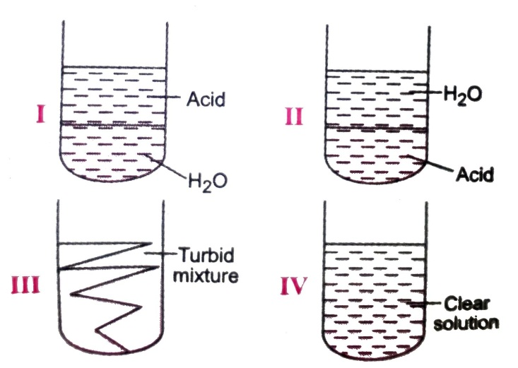 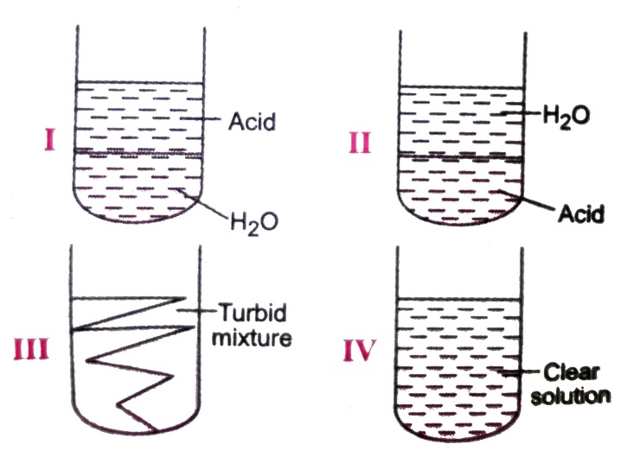

|  |  |  |  |
| --- | --- | --- | --- |
| a) I | b) II | c) III | d) IV |

1. Acetic acid was added to a solid X kept in a test tube. A colourless, odourless gas Y was evolved. The gas was passed through lime water, which turned milky. It was concluded that :

|  |  |
| --- | --- |
| a) Solid X is sodium hydroxide & gas Y is CO2 | b) Solid X is sodium bicarbonate & gas Y is CO2 |
| c) Solid X is sodium acetate & gas Y is CO2 | d) Solid X is sodium bicarbonate & gas Y is SO2 |

1. Ethanoic acid was added to sodium bicarbonate solution and the gas evolved was tested with a burning splinter. The following four observations were reported:
2. The gas burns with the pop sound and the flame gets extinguished
3. The gas does not burn but the splinter burns with a pop sound.
4. The flame extinguishes and the gas does not burn
5. The gas burns with a blue flame and the splinter burns brightly

The correct observation is reported in:

|  |  |  |  |
| --- | --- | --- | --- |
| a) A | b) B | c) C | d) D |

1. The odour of ethanoic acid resembles with :

|  |  |  |  |
| --- | --- | --- | --- |
| a) Tomato juice | b) kerosene | c) Orange juice | d) Vinegar |

1. A few drops of ethanoic acid were added to solid sodium carbonate. The observation made was that :

|  |  |
| --- | --- |
| a) a hissing sound was produced | b) brown fumes evolved |
| c) Brisk effervescence occurred | d) a pungent smelling gas evolved |

1. On adding acetic acid to solid sodium hydrogen carbonate, a student observes the liberation of a

|  |  |
| --- | --- |
| a) Greenish yellow gas with a pungent smell | b) colourless and odourless gas |
| c) yellow coloured , odourless gas | d) colourless gas with smell of rotten egg |

CARBON AND ITS COMPOUNDS Page No. 4

1. Test tube A contains distilled water, test tube B contains rain water while test tube C contains tap water. Ten drops of soap solution were added to each test tube. The tubes were then shaken vigorously for the same period of time and then allowed to stand. It was observed that

|  |  |
| --- | --- |
| a) Foam was formed in test tube A | b) Foam was formed in test tube B |
| c) White precipitate was formed in test tube C | d) All statements are correct |

1. Which of the following represents a soap molecules

|  |  |
| --- | --- |
| a) | b) |
| c) | d) |

1. The cleansing action of soaps and detergents is due to :

a) Dissolution of hydrophilic heads in greasy dirt and hydrophobic tails in water

b) Dissolution of hydrophobic tails in greasy dirt and hydrophilic heads in water

c) Both (a) and (b)

d) None of the two

1. The cleansing action of soap is maximum in :

|  |  |  |  |
| --- | --- | --- | --- |
| a) Sea water | b) tap water | c) distilled water | d) all have equal action |

1. Detergents can be used for washing of cloths

|  |  |
| --- | --- |
| a) only in hard water | b) only in soft water |
| c) both in soft and hard water | d) None of the above |

**Answers**

|  |  |  |  |  |  |  |  |
| --- | --- | --- | --- | --- | --- | --- | --- |
| 1. c | 1. d | 1. a | 1. c | 1. c | 1. b | 1. a | 1. b |
| 1. a | 1. d | 1. a | 1. d | 1. b | 1. a | 1. c | 1. c |
| 1. c | 1. d | 1. c | 1. a | 1. b | 1. c | 1. d | 1. c |
| 1. d | 1. a | 1. d | 1. d | 1. a | 1. c | 1. b | 1. c |
| 1. b | 1. d | 1. b | 1. c | 1. d | 1. c | 1. b | 1. d |
| 1. a | 1. b | 1. c | 1. c |  |  |  |  |

CARBON AND ITS COMPOUNDS Page No. 5